Summary of CCCA Meeting on Rail Transportation: November 16

WHAT? How will Long Bridge Project planning affect Crystal City?
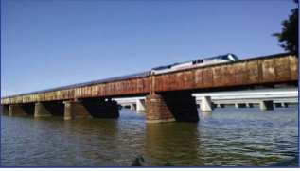
We had an excellent panel of railroad experts who had never participated in such a holistic presentation. Although planning is at an early stage for the Long Bridge Project promoted by the District of Colombia and the Federal Railroad Administration (FRA), there are many implications for CSX, VRE, the Virginia Department of Rail Transportation (DRPT), and Crystal City residents.
Will the train bridge expand from 2 to 3, 4, or 5+ tracks? Will CSX and VRE increase train traffic at night and on weekends? Will VRE upgrade/expand its train station? What are the environmental and quality of life implications for Crystal City?
Long Bridge Project (FRA and DDOT)
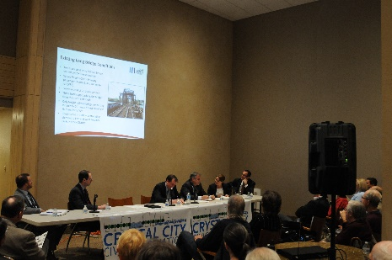
Amanda Murphy, Environmental Protection Specialist, Federal Railroad Administration, and Henry Kay, Project Manager provided an overview of the Environmental Impact Statement (EIS) which is currently underway, the possible alternatives for upgrading the bridge under consideration, and the timeframe. There is a bottleneck at the bridge where 3 train tracks on both the DC and Virginia sides reduce to 2 on the bridge.

CSX
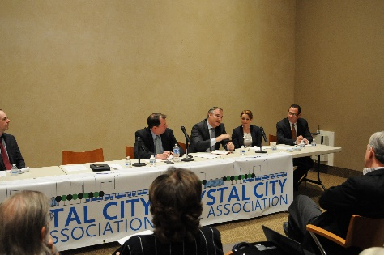
At the outset, Whit Ayres, former Chair of the Air Horn committee, reiterated CCCA thanks to CSX for agreeing to mitigate the train horn noise coming into the VRE station whenever possible. Steve Flippin, Federal Affairs Office, and Randy Marcus, State Government and Community Affairs Office, then went on to explain that 78% of the trains passing through Crystal city are passenger trains (Amtrak; VRE); the rest are CSX trains. CSX owns the Long Bridge and the tracks, so it has the responsibility for safety. Although the majority of resources under the Atlantic Gateway project are aimed at highway projects, a significant amount may also be dedicated to rail and bridge projects. The effects of increased rail capacity transcend the immediate region.

Virginia Railway Express (VRE)
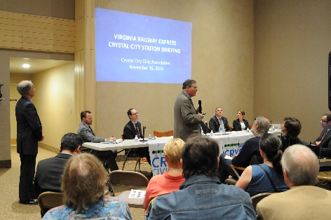
Tom Hickey, Chief Development Officer, explained that VRE is about to kick off its formal study of an upgraded rail station in Crystal City, which is the second busiest station in the system after L’Enfant Plaza. VRE looks at Crystal City as a transportation nexus because of the bus, Metro, and air connections and wants to enhance regional and local connectivity. There is a need for a longer train platform to accommodate 8 car trains and they are considering an overpass vs. underpass option at the tracks. VRE serves about 18,500 passengers per day and the region would need an extra car lane on the roads for peak traffic if VRE didn’t exist. There are two locations for additional station access under consideration, and Hickey promised there will be extensive outreach and consultation with Crystal City residents as the study begins. Key to VRE’s planning is the fourth track considered under the Atlantic Gateway project and which is also essential to DRPT’s planning for the high-speed trains.

Virginia Department of Rail and Public Transportation (DRPT)
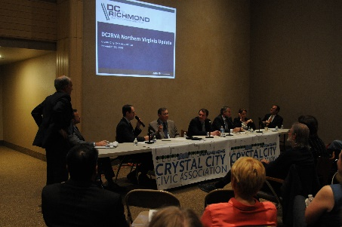
Randy Selleck, Rail Planning Project Manager for the DC-Richmond high-speed project, advised that their draft EIS will be released in December this year, with 60 days for public comment in January and February. They are hoping for a late 2017 Federal Record decision on alternatives. Key to the planning is the proposed fourth rail track in Northern Virginia, with a third track and bypasses to the south. The vast increase in train traffic with these changes would be in passenger trains, not CSX cargo.

Office of U.S. Representative Don Beyer, Eighth District of Virginia
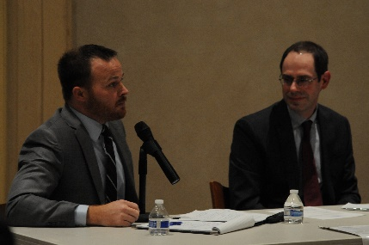
Mike Lucier, who holds the transportation portfolio for Congressman Beyer, noted his office’s role will be threefold: 1) liaison with the public; 2) oversight of funding; and 3) grant opportunities. All panelists noted that there is currently no funding for the Long Bridge expansion and appropriations will be necessary for the infrastructure, regardless of the alternatives recommended and whether private funding is involved. The FRA has been awarded a DDOT grant to do the EIS, but nothing else has been funded. The Congressman’s office will work with the new Administration to project our regional needs and concerns.

Q and A Period:
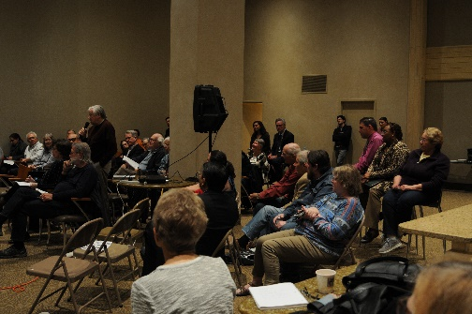

Demand: Asked about the assumptions for growth that are driving these projects, panelists noted that the demand for regional train traffic is growing, with demand for capacity to south and north beyond DC. There is an interconnection between Amtrak and VRE, as each affects the other. Moreover, there was a bigger study of the Northeast corridor with Amtrak anticipating a 43% increase in its own traffic in the coming years. MARC is also projecting growth and knows that it could increase its own ridership if it could reach L’Enfant Plaza and Crystal City.
Noise: Many questions focused on concern for increased horn and engine noise and what would be done to mitigate it. DC and the VRE will both be surveying noise implications in their EIS study, as well as the impact of construction, and will need to consider mitigation measures. CSX suggested looking at the results of the EIS for the Virginia Avenue tunnel in DC, which accounted for many noise impact factors, including the distance from tracks, height of buildings, ambient noise. Although engines have gotten quieter, the difficulty is that walls and similar mitigation factors won’t prevent sound from traveling above the fourth floor in our Crystal City high-rise environment. CSX noted that double stack trains (to double loads) would not necessarily be heavier than existing trains, but more like trucks. DRPT is studying sound as part of the NEPA to be released in December; there are measurements being taken for an ambient noise baseline. Noise mitigation determination depends on the study. The biggest solution to idling noise and soot generation is reducing the bottleneck at the bridge so that trains don’t have to sit and wait their turn. Emissions reduction has been greatly improved in the last 10 years, but unfortunately, engines cannot be turned off while idling; air is needed for the brakes and fuel could freeze in cold weather.
Timeline: Traffic projections are being made through 2040, but the timeline for decisions and construction is difficult since nothing has been funded. Funding is separate for an EIS, design, and construction. As an estimate, construction might take 3-5 years after funding.
Safety: CSX has an excellent service record in the industry, reinvests in maintenance, and has high-tech maintenance machines and a real time view of traffic by safety officers. New sonar equipment can detect problems inside the wheels, and there is equipment to look at and between the rails. CSX’s biggest safety factors are: 1) trespasser accidents; and 2) people crossing the tracks. Due to DC restrictions, there are certain hazardous materials that do not move through the area any more. From the CSX website, you can pull up Virginia and see the percentage lists of commodities that pass through. The Federal requirement for Positive Train Control has cost CSX over $2 billion, but CSX is now the second railroad to implement this. VRE is almost done with its equipment upgrade and Positive Train Control will kick in in the future.
Expansion of VRE Service and Station Plans: The VRE 2040 plan was passed in January, projecting more rush hour trains (every 15 minutes) and mid-day service (60 minutes). VRE is not currently considering late night (after 8 pm) or weekend traffic because this is unlikely to be profitable. There are concerns about VRE’s plans to move more passengers into the community through local space because passengers won’t care about property. Residents want to have a voice about placement of the station access and also a contact point to voice concerns after construction. VRE recognizes the need to respond to local citizens’ concerns about the location of station access and promises to engage the community.
VRE in particular promised that there will be follow-up meetings in 2017. The CCCA remains ready to facilitate these meetings.

