Elections of CCCA Officers
Four CCCA officers will be elected at the CCCA Annual General Meeting on November 16. As of November 1, the date that nominations closed, the following are applying:
For President: Christer Ahl
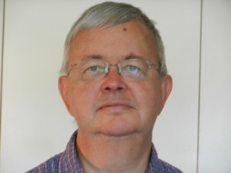
Christer has represented the Crystal City community in Arlington planning processes and on policy issues during the last fifteen years. He wants to enable our Civic Association to continue to draw on his vast experience and his insights by moving on to the position as President of our Civic Association.
From the time of his participation in the Crystal City Sector Planning, Christer has established strong relations with County officials, with landowner and business representatives, and with the leaders of the neighboring Civic Associations. Christer has gained their respect and trust, as evidenced by his many important appointments over the years.
Last year, Christer was appointed to serve as member of a countywide task force, developing recommendations on fundamental issues, such as demographic projections, future income sources, expected needs for County facilities and services, and processes for prioritizing such needs. Christer is also the Vice-Chair of the Crystal City Citizen Review Council, a County entity where all the stakeholder groups monitor progress in Crystal City. He also serves as a Board Member of the Crystal City Business Improvement District (‘the BID’). Earlier, he was on the County’s Parks & Recreation Commission.
Christer’s educational background is in Business Administration, and he spent 30 years as Human Resources Manager at the International Monetary Fund. He also held senior positions in international sports during several decades.

For Vice President for Policy and Planning: Judy Freshman (no photo)
Judy has lived in Arlington for 40+ years and in Crystal City since 2007. Her interests and training (Master of Planning, UVA) have led her to membership on many County task forces and working groups, and she spent 12 years on the Planning Commission from 1983 to 1994. Currently, she is Chair of the Board of Zoning Appeals and has been a representative on the Crystal City Citizen Review Council (CCCRC) since its inception in April 2011. Judy participated in the formation of the Crystal City Civic Association and has served as an ex officio member for several years, primarily monitoring long range and site development plan submissions in Crystal City and Pentagon City.
Treasurer: Diane Oksanen-Gooden
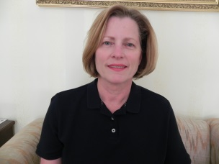
Diane Oksanen-Gooden is a candidate for CCCA Treasurer. She and her husband moved to Crystal City in 2013. Diane is a charter member of Crystal City Civic Association as treasurer. When the opportunity to start a civic association for Crystal City came up, she enthusiastically joined. Diane feels a civic association helps give a community a better sense of having an input into the local government by giving the community a common voice. Diane Has a BS in Chemistry from the University of Pittsburgh. She is a Navy veteran. Diane has worked in research and development in the fields of chemical oceanography and energetic materials. She is presently working in the finance department as cash manager in a privately-held company.
For Membership Liaison: No candidates
Although Teresa Rusin has served in this position this year on temporary appointment by the Executive Committee, there are currently no candidates for the official position. We would welcome participation in this capacity, especially from the apartment rental community, in order to increase representation from that sector of Crystal City.

